TAKE A LEADING ROLE
  - Celebrating LEGACY GIVING, Summer 2023

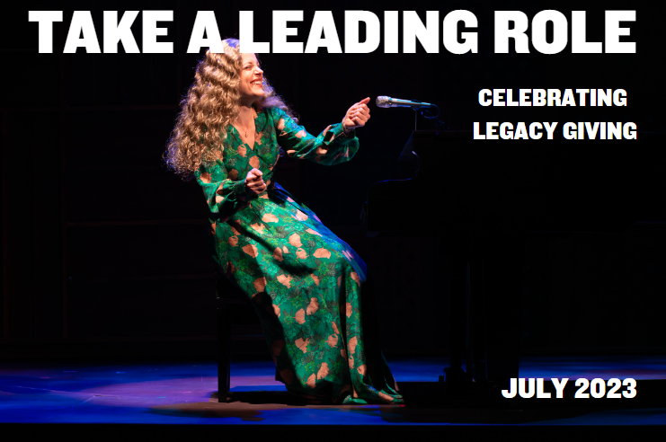

Getting Started with Legacy Planning:
An Interview with Robert Sharman & Richard Bell

Robert Sharman has been an Arts Club patron for almost 20 years. Following his retirement from BMO Nesbitt Burns as Vice President & Senior Wealth Advisor, he has volunteered his time to help grow the Arts Club’s Planned Giving Program. In this interview, Robert explores Richard Bell’s history with the Arts Club and what people need to know when starting to plan their legacy.

Robert: Good afternoon, Richard. I have known you for a number of years, and you are certainly familiar to many Arts Club patrons and donors. For those that don’t know you, can you tell us about your background?

Richard: I have practiced law for over 30 years and am the founder of the law firm Bell Alliance LLP. The firm practices in areas of law that most people need, with a particular focus on real estate, Wills, and estate planning. I am also an active member of the community, having been involved in several not-for-profits and charities, including being the past Board Chair of the Arts Club. My current community activities, in addition to ongoing support of the Arts Club, focus on housing. I sit on the boards of Small Housing B.C. and World Housing. On a very personal level, one housing initiative that was very exciting was the redevelopment of my property into the “Bell Family Compound”. Four generations of my family share three units on land that initially was my single-family home. It is an incredibly supportive way of living with the youngest being my 2-year-old granddaughter and the oldest my 94-year-old mother. For me, family and community are what’s important.

Robert: Today I’d like to focus on the estate planning you do for individuals. What drew you to estate planning?

Richard: I started my practice over 30 years ago with a focus on real estate. I would help young couples buy their first home, move up to new homes as children arrived, and then look at their legacy. I have been going through the same cycles myself, so estate planning became a natural transition. Family is important to me and helping families through these cycles I view as part of my legacy.

Robert: I know you are a busy man, so why your involvement with Arts Club? What attracted you to help this particular organization?

Richard: I think a successful community needs cultural amenities. I have always been a fan of live theatre and what particularly attracted me to the Arts Club was the variety and quality of the productions. Live theatre needs to go beyond the commercial blockbuster singing and dancing shows. That is a fun part of theatre, but it also needs to challenge us as individuals and as a community on different levels. The Arts Club’s productions do that. They are also of a scale that creates opportunities for thousands of talented artists to have successful careers in B.C.

Robert: You’ve done a lot at the Arts Club—frankly you are an inspiration to many. Can you give us a sense of what you’ve done over the years?

Richard: Thanks for those kind words. The good news is I am one of many who have worked hard for the Arts Club for almost 60 years and so many have contributed far more than I can ever hope to achieve. I was invited to sit on the Board by the then Chair, Ross Paul. He was aware of my support for the Arts Club and thought having a lawyer on the Board would be a good idea. I then moved through the ranks of the Board, being asked to be Vice Chair and then Chair.

During my time on the Board there were exciting changes: the move to Olympic Village and the transition from the wonderful Bill Millerd to the incredible Ashlie Corcoran. You mentioned my role in the establishment of the Legacy Circle and it is the contribution of which I am most proud. Many years ago, I would sit in the Stanley Theatre and look around at the audience thinking I was younger than the average age. That is no longer the case, but I realized we at the Arts Club were not spending enough time asking our supporters to include a gift to the Arts Club in their Wills. Since we started asking the question the response has been fantastic, in major part due to the leadership of Bill Millerd.

In addition to my direct involvement with the Arts Club, Bell Alliance LLP hosts a night at the Stanley for over 200 of our strategic partners. Many of those attending love the experience and attend additional shows, with some even becoming season subscribers.

Robert: I understand most of your personal practice is in the area of Wills and Estate Planning. How has this changed over the years?

Richard: I have seen significant changes largely due to our ageing population. Most baby boomers have gone through the challenges of dealing with ageing parents and have lost one or both parents. Within the older population many have lost a spouse or other loved one. This has heightened the awareness of the importance of planning for death and for incapacity. For younger couples, estate planning hasn’t changed significantly. Their Wills mostly give their assets to each other and upon the last to die, to their children. For older couples, we often see gifts not only to their children but directly to grandchildren as they want to have that direct connection on their passing. If an adult child predeceases and had been in a long-term relationship, older parents may include something for the deceased child’s spouse as well as the grandchildren. We are also seeing an increase in bequests to charities.

Robert: Before I retired as a Wealth Advisor, I would work with my clients to ensure their estate planning was updated. One of the challenges I had was getting across the finish line. Who wants to contemplate their death? Do you have any tricks or tips to help people move forward?
Richard: I guess my favourite “trick” is a statement that I and all my lawyers are trained to say to new clients: “I assume you have done your Wills.” It is embarrassing for them to admit they have not, but it usually motivates them to move forward. And when clients say they should get their estate planning done, we let them know that we will follow up to start the process as opposed to suggesting they contact us when they are ready.

Robert: Why is it important to have a Will?

Richard: If you don’t have a Will, provincial legislation decides who inherits your estate and that may not be what you want. For example, most people believe that if a spouse dies the surviving spouse inherits. Unfortunately, if there are children of the marriage, that is not the case. Under legislation, if a spouse dies and there are children, the spouse gets the first $300,000 of the estate and half of the balance. The other half is divided equally between the children. And of course, none of the charities that someone has supported during their lifetime will receive any of the estate.

Robert: My understanding is the Province of British Columbia has unique challenges in terms of navigating estate planning. Can you give us a sense of those challenges?

Richard: What is unique in BC is the ability for a child or spouse to make a claim against an estate if they feel they have been unfairly treated in a deceased parent’s or spouse’s Will. This legal remedy is provided under the Wills, Estates and Succession Act and is referred to as “Wills Variation.” So, for example, if parents wish to disinherit a child, the child could bring an action against the estate resulting in lengthy delays in distribution to the beneficiaries and increased legal fees. The courts tend to focus on whether or not there is a moral obligation to provide for a child or spouse. Needless to say, the test is a bit subjective.

Robert: So how do you navigate around those? What should people do?

Richard: There are a couple of techniques to avoid “Wills Variation” with the most common being the creation of a trust. A couple with one spouse who is at least 65 years of age or an individual parent who is at least 65 years of age can transfer their assets into a Joint Partner Trust or an Alter Ego Trust. The trust would provide for distribution to beneficiaries in the same manner as a Will, but the assets pass to beneficiaries under the trust and not a Will so there is no Wills Variation claim.

Another option is a gift of the right of survivorship. This structure is a bit difficult to explain in a short response so anyone interested in avoiding Wills Variation claims should consult with their professional advisor.

Robert: When it comes to including charities in Wills have you seen any changes throughout your career?

Richard: There have been definite changes since I started my practice. Again, demographics have played an important role. The fastest growing segment of the population has been the over 65 cohort which now accounts for almost 20% of the population. And that population has accumulated significant wealth due to the level of home ownership. Over 75% of adults over the age of 65 own their homes. This has resulted in tremendous generational wealth transfer and has created the opportunity for older adults to give to the causes that they have been passionate about and likely supported during their ageing years while continuing to leave significant bequests to their family.

Robert: From your perspective, why should individuals consider charitable giving through their estates?

Richard: There are a few reasons. First, I believe we are very fortunate to live in Canada. We have our challenges, but Canada has one of the most stable political and economic environments in the world. This has enabled Canadians to enjoy a standard of living that has created opportunities to build wealth particularly through home ownership. Giving to charity is just one way we can all share our good fortune with others. Second, there are some tax benefits where the deceased had invested in publicly traded securities. There is no capital gain tax payable on securities that are gifted to charities. In addition, the estate receives a charitable tax receipt for the value of the securities which could eliminate or reduce other estate tax liabilities. Lastly, it is just the right thing to do. Charities need to be supported as they all contribute to making life better for Canadians and others around the world that are less fortunate. To quote Winston Churchill, “we make a living by what we get, but we make a life by what we give.”

Robert: What is Probate?

Richard: Probate is the process of obtaining court confirmation of the appointment of an Executor if there is a Will or an Administrator if there is no Will. A financial institution, land title office, or other institutions will not recognize the legitimacy of the appointment of an Executor or Administrator without court confirmation as it exposes the institution to liability in the event of fraud. There is a probate fee of approximately 1.4% of the value of the estate that will be payable to the provincial government.

Robert: Is there any way to avoid probate?

Richard: There are a few ways to avoid or reduce probate fees. Any assets that are held in “joint tenancy” or assets that provide beneficiary designations pass directly to the survivor in the case of a “joint tenancy” or to the beneficiary in the case of assets that can be distributed by beneficiary designations. In terms of the latter, this would include RRSPs, RRIFs, TFSAs, insurance policies, and pension plans. These assets do not pass under a Will. An example of “joint tenancy” is, for most couples, their principal residence. When a spouse dies the surviving spouse automatically inherits the property by what is known as the “right of survivorship”. So, for couples we suggest they review their assets and, where possible, ensure all assets are held in “joint tenancy.” For a senior client who has children, we will look at adding a child to the assets. In these situations, we also prepare a “Bare Trust” which is a document that states the child is holding the assets “in trust” for the parent. The parent is the true owner but upon death we can get the assets into the child’s name who will then be holding “in trust” for the parent’s estate. The assets can then be distributed directly to the beneficiaries, thereby avoiding probate, legal fees, and significant delays in distribution.

Robert: What planning activities can one take to minimize taxes and fees?

Richard: Other than probate fees, there are very few strategies to reduce the other significant tax—capital gains. When a person dies, there is a deemed disposition of all their assets. For tax purposes it is as if the deceased sold all their assets upon death. So, if the deceased owned an investment property, the deemed disposition would trigger a capital gain tax. One of the few ways to reduce taxes, assuming the deceased has shares in publicly traded securities, is to include a gift to charities. If the charities receive their bequest as publicly traded securities, there is no capital gain taxes payable in the increased value of the securities and the estate receives a full charitable tax receipt which can be used to offset any other taxes payable by the estate.

Robert: You mentioned incapacity. What documents do you recommend to clients to deal with the potential inability for them to manage their affairs?

Richard: We always recommend that clients have a Power of Attorney and a Representation Agreement. A Power of Attorney appoints someone to manage legal and financial matters. A Representation Agreement appoints someone to manage health care matters. Most couples will appoint each other but we do suggest that they have someone as another option just in case the person who has been appointed is unable to act.

Robert: If you had one piece of advice to give to people about Wills and Estate Planning what would it be?

Richard: Just do it! It is the best gift you can give your loved ones.

To learn more about different methods of
how to leave a legacy, watch “The Show
Must Go On, leaving a Legacy” featuring:

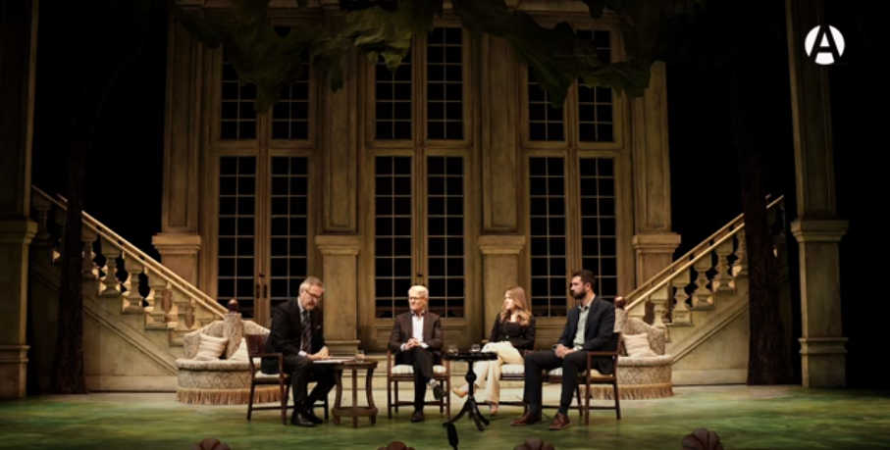
Marissa Elliott
Co-Founder & Financial Advisor, MFA-P
Elsay Wealth

Rhys Webb, TEP
Senior Trust Officer
BMO Private Wealth | BMO Trust Company

Richard Bell B.A. L.L.B
Founding Partner
Bell Alliance LLP

Moderated by,

Robert Sharman
SVP & Senior Wealth Advisor (retired)
BMO Nesbitt Burns Inc.

Watch now on our YouTube channel: https://youtu.be/HlHAnDAItQI.

The Radar Reading Series: New Works in Progress
The Radar Reading Series is one of the Arts Club’s most exciting commitments to developing new Canadian plays. The series of play readings will take place August 21-24, 2024, at the Newmont Stage at the BMO Theatre Centre. Over these four days, we will present four readings of plays written by local artists and performed by professional actors. Each of these pieces has gone through many drafts to the point where the next step is to hear it read out loud in front of a live audience. Following each reading, there will be an opportunity for the audience to give feedback to the playwrights. Our lineup this year features,

- Bella Luz by Alexandra Lainfiesta (a Silver Commission)
- Reproduction by Amy Rutherford
- What a Beaut! by Meghan Gardiner & Dave Deveau (a Silver Commission)
- Tao of the World by Jovanni Sy

Inscribe Your Legacy
Consider leaving your legacy in a different way: inscribe your name, a tribute to a loved one, or some words of wisdom on a seat plaque that will remain in our theatres for 10 years.
Seat plaques at the Stanley Industrial Alliance Stage are $1,000 and $350 at the Granville Island Stage and the Newmont Stage at the BMO Theatre Centre.
Your gift is fully tax-deductible and directly supports theatre education initiatives, new play development, and the productions you see onstage.
Phone Rebecca Paterson at 604.687.5315, ext. 847 or email
donations@artsclub.com for more information.
The Arts Club Theatre Company is a not-for-profit registered charity (no. 119213551RR0001).

