TAKE A LEADING ROLE
  - Celebrating LEGACY GIVING, FALL 2021

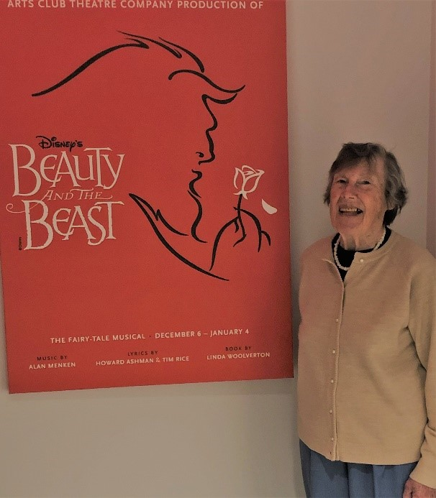
SHEILA, WELCOME TO OUR LEGACY CIRCLE!
The Arts Club is pleased to introduce one of our newest Legacy Circle members, Sheila Cox. “Legacy giving is important to keep the Arts Club growing. COVID-19 has meant that there was no theatre for many months, people lost their jobs, and it was devastating for the arts community. Now, relationships have to be re-established and future audiences attracted. All this costs money and further insight and planning.”

Sheila has been supporting the Arts Club from the very beginning and has followed the Arts Club for five decades. “The Arts Club has grown stronger and stronger. From limited beginnings in the 1960s to becoming a top theatre company in Western Canada with a loyal audience of tens of thousands. From its beginnings at a gospel hall and a garage repair shop, to the three successful theatres, Granville Island Stage, Stanley Industrial Alliance Stage on Granville Street, and the latest, the Newmont Stage at the BMO Theatre Centre.”

Sheila has seen everything change for the better. “I think the growth has been very, very clever and Bill Millerd has been brilliant. He was cautious but forward thinking.” Bill helped save the old Stanley Theatre in 1998, and negotiated for space with the city in 2015 to open the BMO Theatre Centre in the Olympic Village. Sheila loves the way the Arts Club discovers and supports new playwrights and performers. She is impressed by how the Arts Club is collaborating with other theatre groups across Canada and has grown to be the largest not-for-profit urban theatre company in Canada.

When asked about her favourite productions, several memories return. From her time volunteering at the theatre, Sheila had the opportunity to see many, many productions. She shares with us many details about Light Up the Sky the first play at the Seymour Theatre. “The leading man was Wally Marsh, a professional actor. And he was absolutely first rate! Seymour Theatre productions were so popular that people lined up outside two deep for at least an hour before the performance on the off chance someone didn't come and they could get their tickets!”

Another favourite was My Three Angels. “Once more I was doing props and the play took place in July. And it was a Christmas play. Now in July you don’t have Christmas things, and I was supposed to find a Christmas tree. So I thought ‘oh my lord’ where can I get one? Back in those days I had a bicycle so I cycled out to the university endowment lands. I had a saw with me which I’d borrowed, and I found about two thousand little trees that would all work. I sawed this little tree and it was you know, less than a metre high, but it would have worked as a Christmas tree. So I cut it down and attached it to the bike, with the saw. I was riding back from the endowment lands when I was overtaken by a police car. In the car were two policemen and they said ‘aha, what are you doing with that tree?’ One of them, he looked absolutely terrifying, seemed very upset with me. I said ‘well it’s actually part of a play’ ‘What?!’ and I said ‘well, we need to get a small tree to act as a Christmas tree in a play that’s happening at the Arts Club’. Continued…
Page 1P
Well of course, they’d never heard of the Arts Club, so I then proceeded to tell them all about it and they actually began to laugh. And so they let me go back with the Christmas tree, to Seymour Street. I’d taken the policemens’ names because I thought to myself, ‘I must do something to thank them’. And so with Yvonne Firkins’ approval, we sent them tickets to the play. And they both came! And they both enjoyed it. The other thing was, under hot lights, you know 500 watt, large theatre lights, the tree began to wilt. And after one week, it began dropping needles. There was no way I wanted to cycle out to the endowment lands and try to cut down another tree. I went out and bought a can of green paint spray, and sprayed it with green paint and rehung the decorations and nobody complained. I’m sure they noticed it was a very strange looking tree but anyway, in July, what can you expect!”

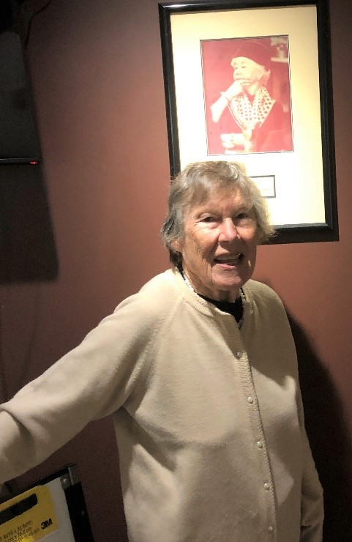
“From a tiny theatre in the round, to three large stages, the Arts Club has become a major employer in Vancouver. I think that’s terribly important, because many people don’t realize the number of creative forces necessary to produce good theatre. Actors and directors are sometimes brought in from across Canada to share their talent. Sets are shipped from other companies such as Matilda coming to us from the Citadel Theatre.”

As a longstanding member of the Arts Club audience, I am amazed at its achievements. I am happy to see the Arts Club expanding into communities such as the Tri-cities, Surrey and New Westminster. Like most theatre lovers, I was sad to see how much the pandemic impacted what we enjoy so much. My hope is that my legacy gift will support many future Arts Club performances and creative programs for youth education, as our youth are the future of theatre.”

Left: Sheila stands by a photo of Yvonne Firkins, whom she volunteered for at the Arts Club.
Did you know the arTs club has a foundation?
it’s the gift that keeps on Giving!
Some donors prefer leaving their legacy gift to the Foundation’s endowment knowing that their donation remains in the endowment and is invested. Each year the annual interest is transferred to the Society to support our mission based work.
The Arts Club Theatre Foundation’s endowment also holds the Bill Millerd Artist Fund and the Denis Simpson Fund. The Bill Millerd Artist Fund directs funds to the Society to specifically support grants for BC theatre artists who wish to develop their craft.
The Denis Simpson Fund came about last year after many internal Arts Club discussions about how to best institute long-term, sustainable, systemic change and provide greater opportunity for artists from equity seeking communities. This fund will help support ongoing apprenticeships, commissions, internships, and much more. The annual distribution from the foundation will be used exclusively towards supporting the continued decolonization of the institution.
If you are interested in leaving a gift to the Foundation, be sure to include in your will, the legal name and CRA Charitable Business Number as below:
Legal Name: The Arts Club of Vancouver Theatre Foundation
CRA Charitable Business Number: 82533 3347 RR0001
Page 2
ELIMINATE CAPITAL GAINS TAX BY MAKING A CHARITABLE DONATION:

If you are planning to make a charitable gift this year, consider this tax saving strategy. Avoid capital gains tax by making a charitable donation of publicly-traded securities to a registered charity. Qualified securities may include shares, exchange traded fund (ETFs) and bonds listed on a prescribed stock exchange and shares/units of mutual funds.

By donating securities directly to a charity of your choice, you have an opportunity to reduce the tax you would otherwise have to pay on the sale of your investments. As with any sale, a donation of securities is considered a disposition for tax purposes. However, as a result of these tax incentives, the taxable capital gain that would otherwise be realized on a donated publicly-traded security can be eliminated.

Making a donation of securities is a great way to maximize your tax savings and at the same time impact the Arts Club new play development and education initiatives. Many use this tax saving strategy to make their annual donation but it can apply to your estate as well to reduce taxation at end of life.

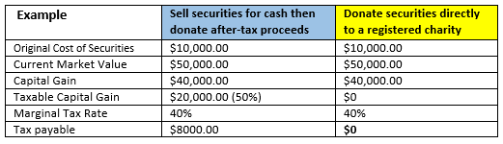

To learn more please contact our Legacy Planning department, who can work with your financial advisor to help you. To access the Arts Club Securities Donation Form, go to our website: https://artsclub.com/support/ways-to-give or contact us directly at 604.687.5315 x281.

“As a lover of live theatre, I feel it is important to support the Arts Club through a gift in my estate.”
Betty McGowan, Legacy Circle Member

Richard Bell and his firm, Bell Alliance have been generously sponsoring the Arts Club since 2007. In 2014, he became the official sponsor of our Leave A Legacy program. Every October the Arts Club recognizes our Leave A Legacy members and his sponsorship helps fund our newsletter and donor recognition. Please CLICK HERE to learn more about Richard and Bell Alliance.

Page 3P
LOOK WHO JOINED OUR LEGACY CIRCLE!
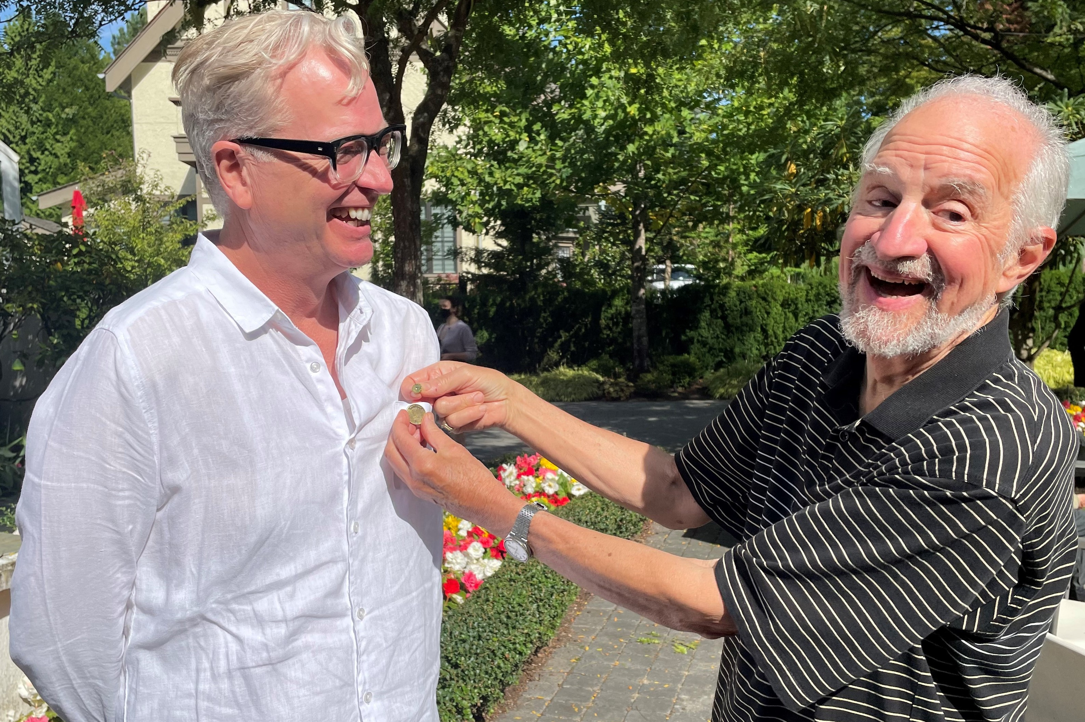
Peter Cathie White, Executive Director, has been with the Arts Club for 18 years. Originally as our Director of Sales and Marketing then moving to his current role in 2014.
Left: Bill Millerd, Artistic Director Emeritus and
Honorary Chair of the Legacy Circle presents Peter with his Arts Club Legacy pin at the recent donor recognition event held in early September.

Peter…..“To me, theatre builds culture. It informs us of who we are collectively and creates our myths and story’s about ourselves. As someone who straddles two cultures, I have grown to really value the way theatrical story-telling enlivens and challenges our beliefs about ourselves. And I know it needs our support. Great art has always depended upon the commissions of the community. And I want to play my part in continuing that legacy at the Arts Club because I know this is what we do. And what we should do.”

Are you looking for another way to leave your legacy and support the theatre you love? Consider engraving your name, or the name of a loved one, on a seat plaque that will remain in our theatres for 10 years.
Your gift has a direct impact on theatre education initiatives, new play development, and the work you see onstage. Seat plaques are $350 at the Granville Island Stage and the Newmont Stage, and $1,000 at the Stanley Industrial Alliance Stage.
Call 604.687.5315, ext. 847 or email us at vip@artsclub.com for more information or to purchase yours today.

Page 4
JOIN THE ARTS CLUB LEGACY CIRCLE
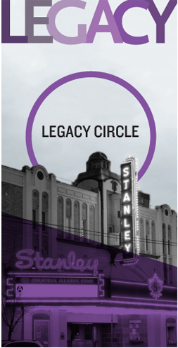
Anyone who loves the Arts Club can make a legacy gift. Large or small, all gifts will ensure that theatre will thrive for generations to come.
Legacy gifts can also provide you with important reductions in estate and income taxes. When making a decision about leaving a legacy, we encourage you to speak with your legal and financial advisors.
Anyone who has left a legacy gift will be welcomed into the Arts Club Legacy Circle—a group of likeminded individuals who share a love of the performing arts.
Legacy Circle members are recognized in each of our play programs and in our annual report. If you choose to remain anonymous, we assure you that your information is kept in strictest confidence.
If you have already included the Arts Club in your estate plans, please consider letting us know. This way we can ensure that your wishes are carried out in the manner you have intended.
To join the Arts Club’s Legacy Circle, please contact Catherine Gautreau, Associate Director of Fund Development, at cgautreau@artsclub.com or 604.687.5315, ext. 261.

The Arts Club Theatre Company is a not-for-profit registered charity (no. 119213551RR0001).

